Extraordinary 84th CRC session in Samoa: Programme of Work and Activities
Where? Taumeasina Island, Samoa
As of 25.02.2020 (subject to changes)
DATE | TIME | ACTIVITIES
Monday, 2 March | 8-9am |  | Traditional welcome
 | 9-11am | 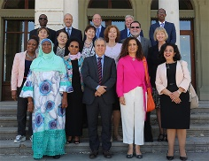 | Session opening  The session starts! The Committee on the Rights of the Child adopts its programme for the week and shares some news on its work
 | 10-11am | 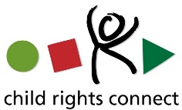 | Briefing with Samoan children  Child Rights Connect prepares the children for their meeting with the Committee and answer to their questions
 | 11am-12.30pm |  | Meeting with Samoan children  The Committee meets with 120 children to discuss about children’s rights
 | 12.30-2.30pm | 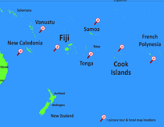 | Side-event with the Committee  A discussion on Human rights and Children in the context of the Pacific
 | 2-3pm | 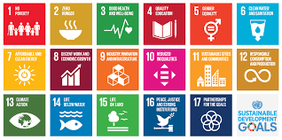 | Side-event  A discussion on how human rights and the Sustainable Development Goals are put in practice
 | 3-4pm |  | Side-event  A discussion on what are the United Nations human rights experts and how can they help in the Pacific
Tuesday, 3 March | 8-9am |  | Tuvalu Session briefing  Child Rights Connect explains to child rights defenders, including children, what will happen during the session and what they can do
 | 9am-12pm |  | Tuvalu CRC Session Part I  The Committee on the Rights of the Child talks to the government of Cook Islands about the state of children’s rights in the country
 | 12-2pm |  | Side-event with the Committee  Dialogue on the Right to Health of Children in the Samoan context
 | 2-3pm | 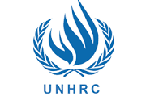 | Side-event  A discussion on what is the Human Rights Council of the United Nations
 | 2-4pm |  | Tuvalu CRC Session Part II  The Committee on the Rights of the Child continues to talk to the government of Cook Islands about the state of children’s rights in the country
 | 4-5pm |  | Tuvalu Session debriefing  Child Rights Connect explains to child rights defenders what they can do after the session
Side-event
A discussion on how the National Human Rights Institutions, the independent persons whose job is to promote the views of children and protect their rights, work in the Pacific
Wednesday,  4 March | 8-9am |  | Micronesia session briefing  Child Rights Connect explains to child rights defenders, including children, what will happen during the session and what they can do
 | 9am-12pm |  | Micronesia CRC Session Part I  The Committee on the Rights of the Child talks to the government of Micronesia about the state of children’s rights in the country
Side event
A discussion on how NGOs and children can send a report to the Universal Periodic Review, where human rights in all UN Member States are reviewed
 | 12-2pm |  | Side-event with the Committee  A discussion on how children’s rights are respected in the context of emergencies
 | 2-4pm |  | Micronesia CRC Session Part II  The Committee on the Rights of the Child continues to talk to the government of Micronesia about the state of children’s rights in the country
 | 3-4pm |  | Side event  A discussion on ending child labour
 | 4-5pm |  | Micronesia session debriefing  Child Rights Connect explains to child rights defenders what they can do after the session
 | 4-6pm |  | Capacity building on CRC reporting  Child Rights Connect will train child rights defenders, including children, on how to tell the Committee about how children’s rights are respected in their country
Thursday, 5 March | 8-9am |  | Cook Islands session briefing  Child Rights Connect explains to child rights defenders, including children, what will happen during the session and what they can do
 | 9am-12pm |  | Cook Islands CRC Session Part I  The Committee on the Rights of the Child talks to the government of Tuvalu about the state of children’s rights in the country
 | 12-2pm |  | Side-event with the Committee  A discussion for the Committee to better understand child’s rights issues across the Pacific region and inform future dialogues
 | 2-3pm |  | Side event  An event to meet with the organisation Heirs to the Ocean who empowers children to stand up for the protection of the ocean & earth and achieving Sustainable Development Goals
 | 3-4pm |  | Side event  An event where children from the NGO Brown Girl Woke will use song, dance and monologue to speak about child life in Samoa
 | 2-4pm |  | Cook Islands CRC Session Part II  The Committee on the Rights of the Child continues to talk to the government of Tuvalu about the state of children’s rights in the country
 | 4-5pm |  | Cook Islands session debriefing  Child Rights Connect explains to child rights defenders what they can do after the session
 | 4-6pm |  | Capacity building on child participation  Child Rights Connect trains child rights defenders, including children, on how to support all children to promote and defend their rights in a safe and meaningful way
Friday, 6 March | 9am-12pm |  | Event on CRC 30th anniversary with the Committee  An event to celebrate and discuss the last 30 years of the Convention and new commitments for children’s enjoyment of their rights in the future, as well as to celebrate the 25th anniversary of Samoa’s accession to the Convention
 | 9am-5pm |  | Event on Climate change  An event to discuss how children’s rights are affected by the climate crisis and what solutions can be found
 | 12-2pm |  | Side-event with the Committee  A discussion on how to protect children from abuse, neglect, maltreatment or exploitation
 | 2-4.30pm |  | Event on Climate change with the Committee  An event to present Child Activists of the Pacific and discuss the World of Tomorrow
 | 4:30-5pm |  | Concluding session  The session ends! The Committee closes its session and shares updates on its work
Tuesday 10 March | 10am |  | Concluding Observations publication  The Committee publishes its recommendations to the States of Cook Islands, Micronesia and Tuvalu and the list of questions to the State of Kiribati

