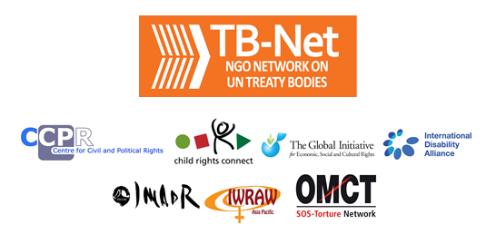

Elections 2020

Committee on the Rights of Persons with Disabilities (CRPD)

Committee on the Elimination of Discrimination Against Women (CEDAW)

Human Rights Committee (HRCttee)

Committee on the Rights of the Child (CRC)

  - Questionnaire for candidates
Four UN Treaty Bodies (Committee on the Rights of Persons with Disabilities (CRPD), Committee on the Elimination of Discrimination Against Women (CEDAW), Human Rights Committee (HRCttee) and Committee on the Rights of the Child (CRC)) will have elections organised in June 2020.
In order to strengthen the treaty bodies, the International Disability Alliance, Child Rights Connect, IWRAW Asia-Pacific and the Centre for Civil and Political Rights – as part of TB-Net, the NGO network on the UN Treaty Bodies – seek to promote quality, independence and diversity of treaty body membership through transparent and participators nomination and elections processes.
This questionnaire, which is sent to all nominated candidates and is based on the criteria set forth in the relevant treaties and in the GA Resolution 68/268, will enable all States and other stakeholders to better understand the skills, experiences and motivation of running candidates to CRPD, CEDAW, HRCttee, CRC in advance of the elections.
The written responses to the questionnaires will be made available on the website www.untbelections.org, while the video responses will be shared on a dedicated YouTube page.
This initiative does not imply that we support or oppose any individual candidates.

Questions for all treaty bodies candidates

1. Name: Velina Todorova

2. Nationality: Bulgarian

3. Current position: Member to the CRC Committee, serving a first term (2017-2021). Elected as a Vice Chair in 2019.

4. Are you currently holding or have you previously held any position on behalf of, or for, your Government (Executive branch) that may compromise your actual or perceived independence and impartiality? If so, please give details:

I was part of the Government in 2000-2003 as a Director of Programmes and International Relations Department at the (just established) Agency for Child Protection. In 2011-13 I was a Deputy Minister of Justice. I declare that those past positions at the Executive do not compromise my independence and impartiality as an expert on the rights of the child.

5. Please indicate any current or potential conflict of interest that may prevent you from exercising independence and impartiality in your work as a member of a UN treaty body:

I declare that I do not have any current or potential conflict of interest that may prevent me from exercising independence and impartiality in my work as a member of a UN treaty body.

6. Was the nomination process for your candidacy a transparent and participatory process? Was civil society or other relevant stakeholders involved?

The Ministry of Foreighn Affairs leads the nomination process in Bulgaria. The Minister heads a National Coordination Mechanism on Human Rights establisehd by a Government Decision N 796/19.12.2013. All candidates for elections to treaty bodies, including my candidacy, are discussed and approved by a decision of the National Coordination Mechanis, which makes the process transparent and participatory. Members to the Coordination Council to the Minister of Foreign Affairs are all engaged ministries and agencies such as the Ministry of Labour and Social Policy, Ministry of Interior, Ministry of Justice, Agency for Persons with Disabilities, Child Protection Agency and others as well as civil society organisations such as the National Network for Children, For our Children Foundation, Gender Research Foundation and others.

7. During your possible service as a Committee member, what other positions or professional activities do you intend to engage in?

I will continue my engagement as Associate Professor on Family Law, Civil Status and Rights of Children at the Law Faculty Plovdiv University, and with the Bulgarian Academy of Sciences.
8. The commitments as a Committee member are very time-consuming during and outside session time. Will you have the capacity to dedicate the necessary time to the work of the Committee?

As an academic person, I have the freedom to combine my professional engagements with my work at the Committee on the Rights of the Child.

9. What are the current and main challenges that you see for the treaty body system and what are your ideas for improvement?

The main challenge is to make a good progress in the Treaty Bodies strengthening process in order to facilitate the States parties to meet their reporting obligations but also to maximise the compliance with the Human rights treaties. The Committee has already decided to offer all State parties a Simplified reporting procedure that should decrease the reporting burden on the governments. Resource mobilisation is also needed to make the system function properly and for the benefit of peoples.

Link to your full resume:

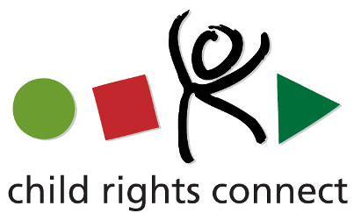

Questions for candidates to the UN Committee on the Rights of the Child (CRC)
Please provide responses that are as precise as possible and in no more than 200 words per question.

1. What motivates you to be a member of the Committee on the Rights of the Child? (video option)

Video is attached

2. Taking into account the current composition and expertise of the Committee, what would it be your added value? (video option)

Video is attached

3. What do you think are the emerging issues and challenges in the implementation of the CRC and its Optional Protocols on a global scale as well as in your country/region?

The newly emerged issue is the socio-economic impact of the COVID 19 pandemic on children and families. The implementation of CRC and its Optional Protocols in the post-pandemic time will need more efforts targeted to the families and children mostly affected by the loss of incomes, access to free education and health care. Increasing inequalities, protection gaps, and attacks against children’s rights and civil society are among the emerging issues that hamper the realisation of children’s rights in my region.

4. What do you think are the areas where the Committee needs to strengthen international child rights standards?

Within its mandate given by the Convention, the Committee concentrates on particular areas of concern with regard to the State party under the review. In many areas the General comments of the Committee contribute to the strengthening of international child rights standards. The needs to strengthen international child rights standards vary from region to region and from country to country. These very much depend on the levels of economic development but the Committee also attempts to encourage positive campaigns, international cooperation, good practices. More attention is still needed in areas such as: protection against intersectional discrimination (i.e. of the girl child and children with disabilities), a proper and genuine evaluation and determination of the best interests of the child and groups of children; empowering of children; protection from violence; alternative care and access to free and inclusive education and justice.

5. How do you envision the work of the CRC Committee in the achievement of the Sustainable Development Goals?

The Committee established a Working group on this matter in order to keep the focus on the progress of SDGs achievement. Since the relevant SDGs and/or targets are integrated in the reporting procedure under the Convention, the Committee should remain attentive during the reviews and COBs drafting on the realization of children’s rights in the process of implementing the 2030 Agenda for Sustainable Development. The Committee’s role is to facilitate the State party to ensure the meaningful participation of children in the design and implementation of policies and programmes aimed at achieving SDGs.

6. How do you think the Committee could advance the standards and practices on child participation and particularly children’s right to participate in political life?

Article 12 of the Convention is clear – as rights holders with evolving capacities, children shall express their views, wishes and ideas and all those should be given a due consideration in decisions affecting children. The Committee provided a comprehensive interpretation of article 12 in a General comment N12 of 2009. Listening to children shows due respect to children as citizens as well as is important for the protection of their rights and best interests. It is particularly true in matters such as school environment, family breakdowns, care and protection from violence. Access to proper channels for children to participate in justice proceedings is of constant concern of the Committee. The Committee applies all the instruments at its disposal – dialogs with State parties, concluding observations, general comments, statements and Days of general discussion to advance the standards on child participation.

7. What can the Committee do to further strengthen its engagement with civil society?

The civil society is considerably engaged with the Committee on the Rights of the Child. The Committee receives submissions, holds dialogs as part of the country reviews cycles, and collaborates in days of general discussion and in other actions. The engagement with civil society could be strengthened by regularising the online meetings and exchanges particularly for the stakeholders in places being far from Geneva or in crisis situations that hamper travelling.

