Call for the inclusion of child human rights defenders into the Law on human rights defenders
As a group of organisations supportive of child human rights defenders, we are submitting this comment on the Concept of the Law on Human Rights Defenders as proposed by the Ombud’s on Human Rights. Our Comment focuses specifically on the integration of the rights of child human rights defenders in the Law proposed by the Concept. This comment is informed by young human rights defenders and their suggestions are included. (More about our group can be found at the end of the document.)
Child Human Rights Defenders are defined considering international human rights standards that are recognised in Moldova. Children are human beings below 18 years of age as according to the UN Convention on the Rights of the Child, and children who take actions to promote, protect and fulfil human rights, including children’s rights, are human rights defenders as according to the UN Declaration on Human rights Defenders even if they do not see themselves as such, or are not considered and called as such by others (see also Child Rights Connect's Guide on the Rights of Child Human Rights Defenders).
Abbreviations:
- CHRD – Child Human Rights Defenders
- UN CRC – UN Convention on the Right of the Child
- UN DHRD – UN Declaration on Human Rights Defenders
- Child Rights Connect (2020) The rights of child human rights defenders: Implementation Guide – CHRD Guide or the Guide

Rationale for our suggestion to integrate CHRDs in the Law on HRD
We welcome this initiative for the Law on Human Rights Defenders (HRDs) as conceptualized by the Ombuds on Human Rights as well as the suggestion for a separate chapter on child human rights defenders (CHRDs) as expressed by the Ombuds for Children's Rights in the Call for Comments on the Concept of the Law (link). This is a significant advancement in our collective demand for a safe, empowering, and inclusive environment for human rights defenders.
We agree with the rationale for a comprehensive Law on HRD as described in the Concept. In addition, the suggestion of the Ombuds on Children’s Rights for a chapter on CHRDs provides a good direction for recognising and integrating in the Law proposed all the rights that children must be able to exercise when acting as defenders.
CHRDs, their rights and the state obligations related to these rights, should be explicitly mentioned both in the Concept and in the Law on HRD itself. This is important because of the following main reasons:
- As in the case with HRDs, this is based on the commitments Moldova took in respect of human rights, including human rights of children. This Law is an opportunity to domesticate the UN Declaration on Human Rights Defenders and the UN Convention on the Rights of the Child that Moldova has ratified. Rights of CHRDs as set out in these two documents are described in the recently published Child Rights Connect's Guide on the Rights of CHRDs. Key international experts including the Special Rapporteur on Human Rights Defenders, members of the UN Treaty Bodies took part in the development of this Guide. The Guide is considered complementary to the Model Law quoted in the Concept. Since the Guide offers detailed guidance on what is distinctive about CHRDs and how to recognise and advance their rights, it is recommended as a basis for developing the Chapter on CHRDs in the Law on HRDs. Related to the “Law, Policy and Implementation” key recommendation of the SRHRD and the CRC Committee reads as follow:
“States should develop and adopt comprehensive national laws and policies on protection and empowerment of human rights defenders, including child human rights defenders, integrating a gender and age sensitive approach with special attention to children in vulnerable situations, including children in humanitarian situations, children in alternative care, indigenous children, and children with disabilities. States should ensure that the national legal framework complies with the Convention and allows children to act freely as human rights defenders.” (link)
- As in the case with HRDs, public awareness about children’s engagement for human rights is growing, along with the awareness about the issues, obstacles and challenges they face. The Committee on the Rights of the Child has held a Day of General Discussion (DGD) in 2018 devoted to this topic (link). The main conclusions and recommendations can be found in the 2018 DGD Outcome Report. Child and young Human Rights Defenders from Moldova took part in the 2018 DGD as well as in it’s follow up. Moreover, they have taken part in the current UPR of Moldova to draw attention to the situation of their rights in Moldova (link). Recognition of CHRD Rights in the Law on HRD will help address main issues and improve their situation. General and specific issues that CHRDs face in Moldova as according to their report should as well be considered and CHRDs themselves should take part in the development of the Chapter on CHRDs of the Law proposed. This would be in line with the recommendation of the SRHRD and the CRC Committee which reads as follow:
“National legislation should be built upon and include the views of child human rights defenders. During the drafting of legislation, States should consult and take into account the recommendations and the requests of representative groups of children, child-led organizations and child participation mechanisms such as children's parliaments” (link)
This recommendation echoes the recommendations made by child and young human rights defenders in their Factsheet: "Establish an exchange platform between child and youth organizations and government, creating a safe space and opportunities for child human rights defenders to express their views and develop policies considering them" (link)
Finally, once a comprehensive and inclusive Law on human rights defenders is developed, existing laws that are relevant and have an impact on HRDs should be reviewed through a child rights impact assessment to ensure they are consistent with the new human rights defender law (eg. the law on peaceful assemblies). We recommend using the Common Framework of Reference for Child Rights Impact Assessment (CRIA) developed by the European Network of Ombudspersons for Children (link).

Specific proposals to be included in the text of the Concept
Page 6:
Termenul „apărător al drepturilor omului” se referă la orice persoană care, individual sau în asociere cu alte persoane, activează pentru promovarea sau protecția drepturilor omului. În primul rând, apărătorii drepturilor omului se identifică cu ceea ce fac, iar cea mai bună modalitate de a explica această expresie este de a-și prezenta munca și contextul în care lucrează, lista activităților acestora nefiind exhaustivă. Apărătorii pot fi de orice gen, de diferite vârste, including those younger than 18 years of age, din orice parte a lumii și din tot felul de medii profesionale sau de altă natură. ADO nu se regăsesc doar în cadrul organizațiilor neguvernamentale, dar ar putea fi, în unele cazuri, și oficiali guvernamentali, funcționari publici sau membri ai sectorului privat.
Page 18:
Introduce a chapter before the one starting “In luna junie …”
Children and young people around the world, including in Moldova, are increasingly defending children’s rights or human rights in general, and acting as child human rights defenders. They are speaking up on many different issues, from the environment to gender discrimination, from violence to alternative care, through many different initiatives such as awareness-raising campaigns (online and offline), protests, monitoring and reporting procedures on the UN Convention on the Rights of the Child or Universal Periodic Review, etc.
Yet as identified in many instances worldwide including Moldova, their activities are not visible, and seldom recognised or supported. Children are often unaware that they have the right to act, be empowered and protected as CHRDs and regularly face risks to their safety. A Factsheet elaborated by a group of young human rights defenders emphasize following main challenges:
- Lack of child/youth friendly information on human rights, including protection mechanism, opportunities, and support for action, etc
- Strong and widespread negative attitudes about children’s capacities and activities of child human rights defenders
- Not-functioning protection mechanisms
- Widespread risks of violence and negative consequences (more details here)
A comprehensive Law on HRD inclusive of CHRD would help answer to the main issues CHRDs face in Moldova, by clarifying that the State should take additional measures to empower and protect CHRDs (as opposed to adult HRDs) because of their specific rights and risks, thereby providing appropriate responses to their recommendations. Such measures would include for example:
- Conduct an awareness-raising campaign to inform children, parents and everyone working for and with children (such as teachers, social workers, police), about human rights, and in particular children’s rights, including what can be done if rights are violated.
- Establish an exchange platform between children's and youth organizations and government, creating a safe space and opportunities for child human rights defenders to express their views and develop policies considering them.
- Ensure that child human rights defenders have access to multiple, safe, child-appropriate mechanisms to report reprisals, violence, and abuse, seek redress for violations and receive support and care for physical and psychological abuse.
Page 23
Proiectul de lege este destinat să acționeze ca un ghid pentru a ajuta legiuitorii și apărătorii în dezvoltarea unui mecanism pentru recunoașterea și protecția apărătorilor drepturilor omului.
To integrate rights of CHRDs in the legal framework the Child Rights Connect's Guide can be of help. The CHRD Guide has been developed with technical inputs by international experts such as the SR on HRDs and the CRC Committee. It has also been supported by the International Service for Human Rights (ISHR), the organisation who coordinated development and published the Model Law. Hence, as addition to the Model Law, the CHRD Guide lends itself as a basis to further develop a chapter on CHRD as proposed by the Ombuds on Children’s Rights. The relevant provisions should include definition of CHRDs, as well as their rights and as state obligations related to respect, protection, and facilitation of their rights as CHRD and as elaborated in the CHRD Guide.

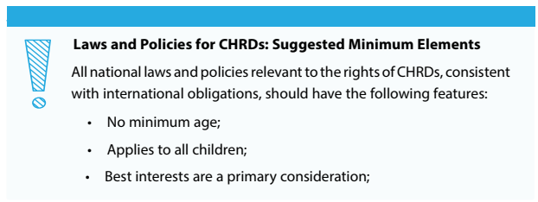
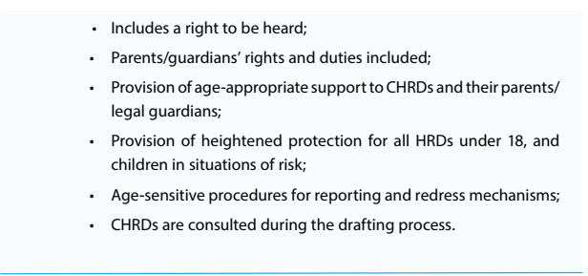
taken from the CHRD Guide, page 94-95.

Our group of organisations & contribution to development of the Law on HRD
Each of our organisations has a long term commitment to children’s human rights as well as supporting children’s interest in human rights including empowering children to engage in human rights.
In 2021 we started with a long-term capacity building process to advance the rights of CHRDs based on the international standards in 2021. The Ombuds on Children’s Rights has actively supported and participated in this process. As a result of this process a situation analysis and a joint action plan have been developed, and we have advocated for the rights of CHRDs in the frame of the ongoing Universal Periodic Review of Moldova. Moreover, a group of young human rights defenders was supported to advocate for their rights in this same process, including to develop and lead a national awareness raising campaign. Our capacity building and advocacy activities have been supported by Child Rights Connect and conducted as follow up to the UN Committee on the Convention of the Rights of the Child Day of General Discussion from 2018.
We would like to express our interest to support the development of this Law, and especially the Ombuds on Children’s Rights in further development of her suggestion related to the Chapter on CHRDs. Moreover, we are interested in supporting CHRD participation in development of this Law and especially its provisions related to the CHRDs and their rights.

Signatories:
- Centrul de Informare si Documentare privind Drepturile Copilului din Moldova (CIDDC) / Child Rights Information Center Moldova (CRIC)
- Alianța ONG-urilor active în domeniul Protecției Sociale a Copilului și Familiei (APSCF) Alliance of Active NGOs in the field of Child and Family Social Protection (APSCF)
- Amensty International Moldova
- Child Rigths Connect
- Terre des hommes Moldova

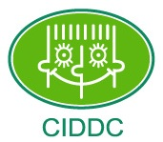 |  | 